Homework-11

Assigned: December 2, 2024 (Monday)
Dynamic Programming, Graph Algorithms: Topological Sort, Shortest Path, MST, Maximum Flow
Due: December 8, 2024 (Sunday)

Problem 1:
Design algorithm to find single source shortest path in Directed Acyclic graph in O(V+E) time. Find the single source shortest path from source vertex 1 in the following graph:
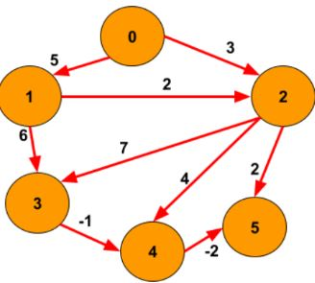

Problem 2: Find the minimum spanning tree in the following graph:
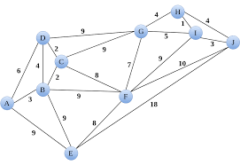
Problem 3: Explain the closest pair algorithm in detail? Derive its recurrence relation and solve it to find its time complexity.
Problem 4: Give the Ford-Fulkerson algorithm to find maximum flow in a network. Find the maximum flow in the below given network:
Source(Leftmost Node)
Sink(Rightmost Node)
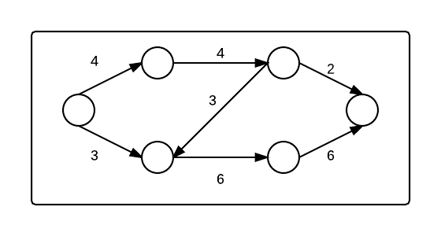

Problem 5: What are flow networks with all its properties? What is maximum flow problem? Give Ford-Fulkerson algorithm and analyse its complexity? Find the maximum flow in the following network with source node A and sink node as J.:

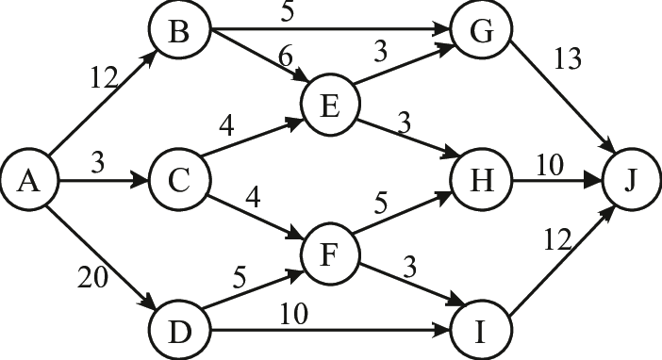

Problem 6: What is negative cycle? How Bellman-Ford algorithm helps in detecting negative cycles? Give bellman ford algorithm and analyse its time complexity. Find the shortest path from source S in the following graph:
